setting up a kick start server

Tasks

1. Install the kickstart package on your Linux server and verify the installation by running the appropriate command.

ANS:

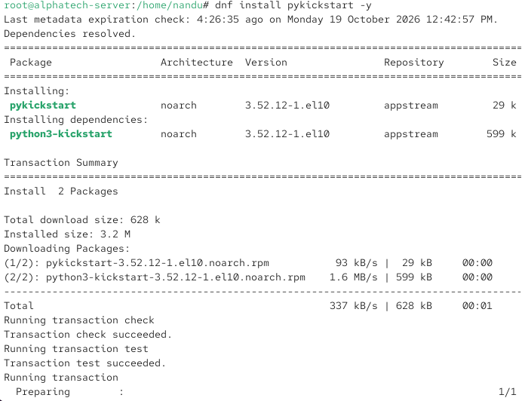

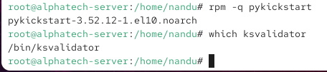

2. Create a basic kickstart configuration file (ks.cfg) that automates the installation of CentOS or Rocky Linux with your preferred timezone, root password, and a user account named 'student'.

ANS:

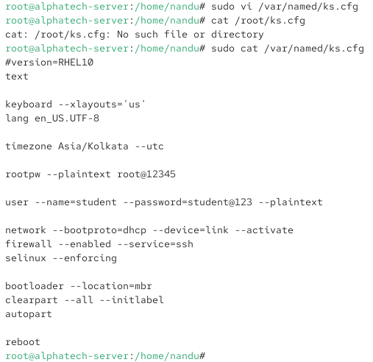

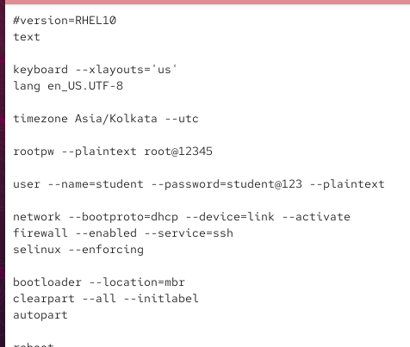

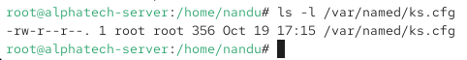

3. Set up an HTTP server (using Apache or nginx) to serve your kickstart file, and confirm you can access ks.cfg from another machine on the network via a browser or curl.

ANS:

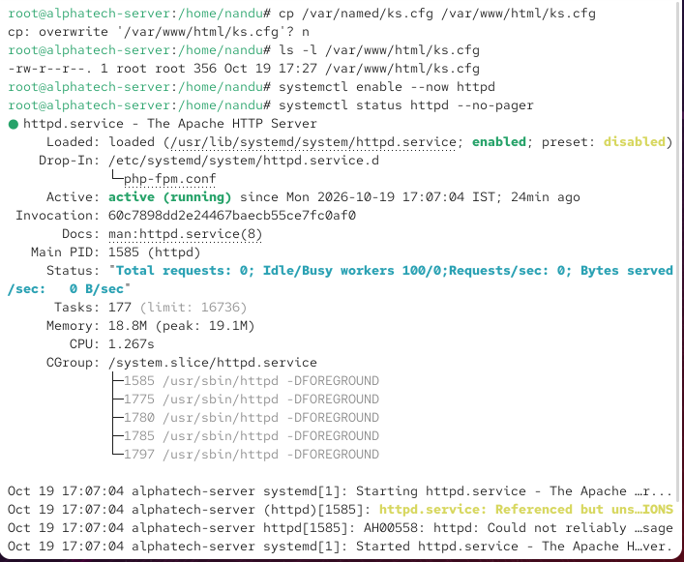

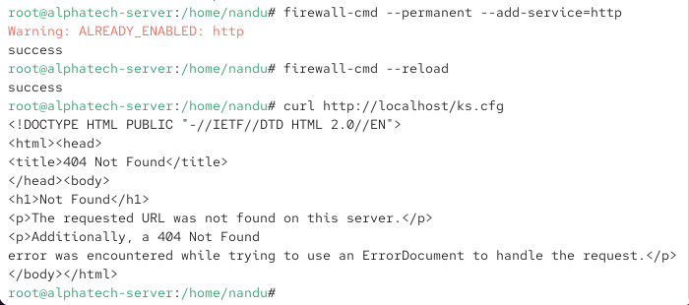

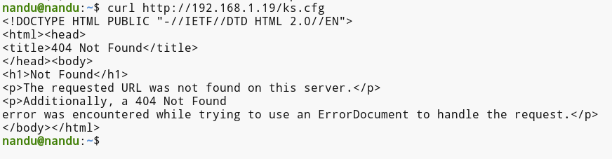

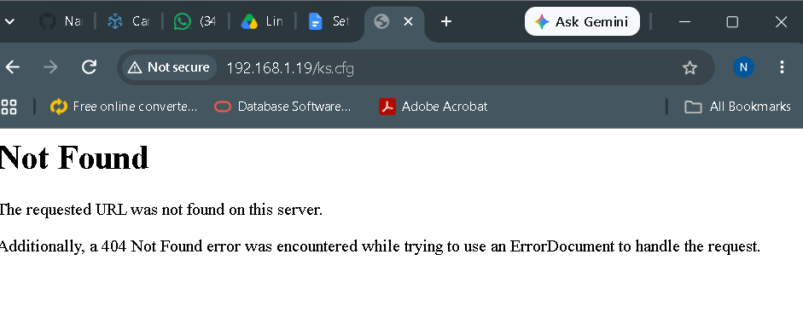

4. Modify your kickstart file to automatically install the GNOME desktop environment and add a post-install script that creates a text file /home/student/welcome.txt with the message 'Welcome to your automated Linux setup!'. Use the %post section in your ks.cfg for post-install commands.

ANS:

